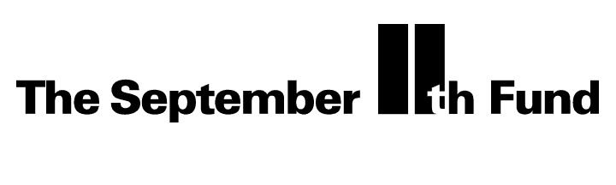

Follow-up from Previous Meeting

We thought it might help to recap key decisions made at the last meeting and describe what we’re doing to implement the policies you decided. In most cases, we have not yet made grants.

Service Coordination, Case Management & Outreach
The Board authorized up to $2 million for initial grants to design and develop coordinated case management and outreach efforts.
To implement this policy, we have made an initial grant of $300,000 to the 9/11 United Services Group to provide start-up funds for the organization (described in the materials) to coordinate training, establish protocols and conduct outreach to providers and affected individuals. We have met with the State of New Jersey and are expecting a proposal for similar service coordination, which we will then evaluate.

Mental Health
The Board authorized the development of a grantmaking program in mental health incorporating: education and outreach (in the NYC and Washington DC, not nationally); treatment for secondary victims; and training for professionals and other involved organizations (e.g., churches) on treatment of trauma.
To implement this, we first must decide (1) Which organizations are best positioned to carry out the education, outreach, and training work? (2) Whether to support treatment by making grants to service providers or instead by working with an insurance company to provide reimbursement of individual’s treatment costs? (3) How to best coordinate our efforts with government and with the Red Cross?
We continue to meet with City and State officials, the Red Cross, and organizations that might provide mental health services and survey the landscape of nonprofit organizations who have the expertise, experience and infrastructure to accomplish the tasks. We will next month either post a "notice of available funds," broadly distribute a "request for proposals", or select organizations with which we wish to work and request a specific proposal from them.

